Create user with name and provide sudo access

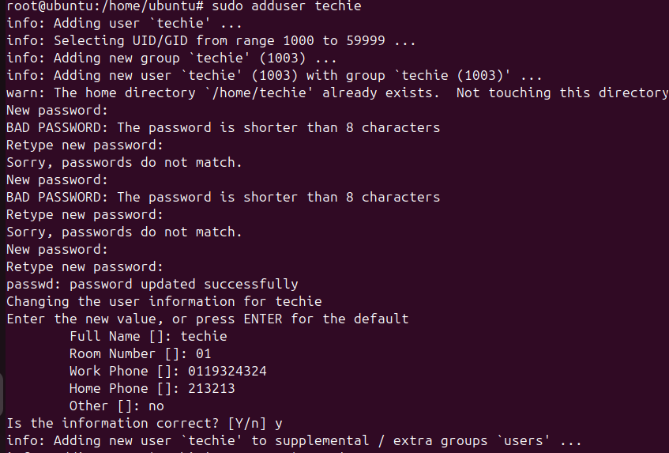

- Sudo adduser < username>
Now set your password , next add ur full name , room number , work phone , home and other
After adding this it ask is information is correct if it correct type (y)
If in case if it wrong just type (N)
- Now the user has been add to our machine

2. Navigate to the home directory
Commands:
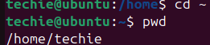
Expected output:
Display /home/techie
Screenshot: terminal showing path

3. Create new directory
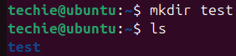
Expected output:
New folder test visible
Screenshot: terminal to check type ls

4. List contents of a directory
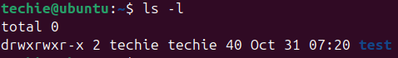
Expected output:
Shown files and directories
Screenshot: output list

5. change the currect directory
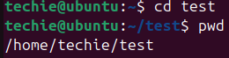
Expected output:
Shown /home/techie/test
Screenshot: path output.
6. Create a new empty file
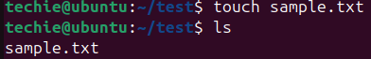
Expected output:
File sample.txt created.
Screenshot: list showing file

7. view contents of a file
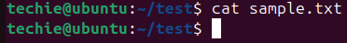
Expected Output:
If empty-no output.
Screenshot: cat command.

8. copy a file to another location
Expected output:
File coped to /tmp/
Screenshot: command and vefitication

9. move a file to another location
Expected otput:
File movied one directory up
Screen shot: before/after ls

10. rename a file

Expected output:
File rename successfully
Screenshot:terminal after ls

11. Delete a file
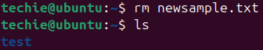
Expected output:
File deleted.
Screenshot:list before/after deletion

12. Grant or revoke permissions
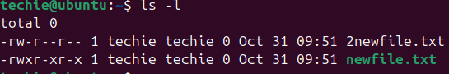
Expected output:
Permission changed
Screenshot:ls –l 2 different txt files

13.View current date and time
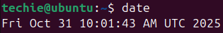
Expected Output:
Current date/time display
Screenshot: output

14. Check system uptime
Expected Output:
Shows time since last reboot.
Screenshot:output

15. view running processes
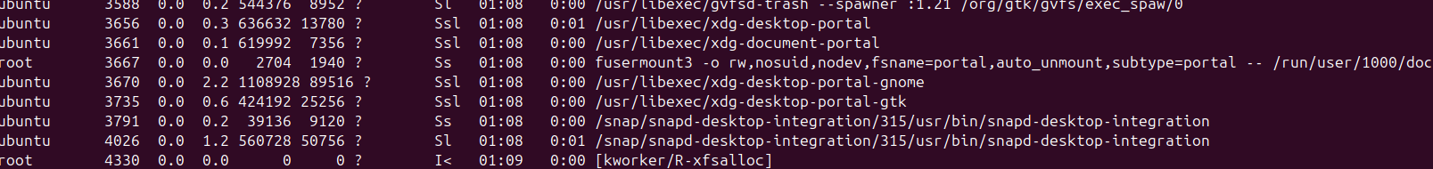
Expected output:
List of running processes
Screen: top few line

16. Kill a running process

Expected outputs:
Process terminated.
Screenshot:before & after process list

